21.41: Two positive charges, , are on the x-axis a distance a from the origin.
a) Halfway between them, 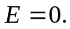
b) At any position 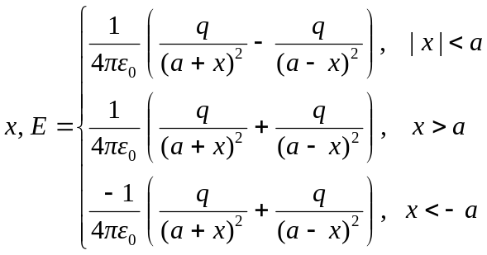
For graph, see below.

